Example No: 1 – Automate Windows Services – Check telnet service status and start telnet service if not started

Task Description

While running terminal commands, telnet service must be in started. For the purposes of this we check whether telnet service is started or not, if not then we will start the telnet service.

T80.atmx

*Note: Save the xls in C: drive, the .atmx file in My Documents -> Automation Anywhere -> Automation Anywhere -> My Tasks*

Solutions

**Create a new task**

* Click on New->Task Editor

**Insert service command to ‘Get Service Status’**

* Drag and drop services command.
* Select ‘Get service status’ option.
* Select Telnet service from the list.
* Select the variable from the list.
* Save the command.

[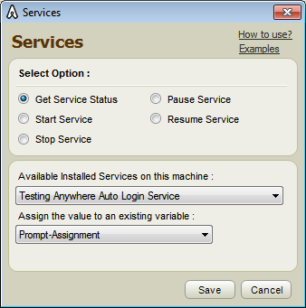](https://tekslate.com/wp-content/uploads/2017/11/T80-1.png)

**Enter if condition to check whether the service is started or not.**

* Select $Prompt-Assignment$ in variable.
* Select Equal to operation.
* Select ‘Fix’ option.
* Type ‘SERVICE STOPPED’
* Save the command.

h3>Insert services command to START service

* Drag and drop services command.
* Select ‘Start service’ option.
* Select Telnet service from the list.
* Save the command.

[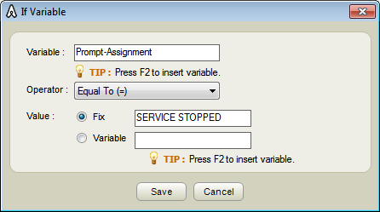](https://tekslate.com/wp-content/uploads/2017/11/T80-2.png)

**Enter Else if condition to check the service is paused or not.**

* Select $Prompt-Assignment$ in variable.
* Select Equal to operation.
* Select ‘Fix’ option.
* Type ‘SERVICE PAUSED’
* Save the command

**Insert services command to Resume Service**

* Drag and drop services command.
* Select ‘Resume service’ option.
* Select Telnet service from the list.
* Save the command.

[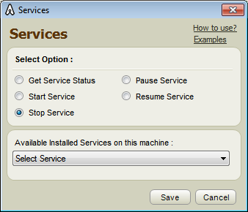](https://tekslate.com/wp-content/uploads/2017/11/T80-3.png)

**Insert all terminal commands which you want to run**

**Insert stop services command**

* After all the terminal commands put stop service command.
* Drag and drop services command.
* Select Stop service status option.
* Select Telnet service from the list.
* Save the command.

**Save and Run the task**

* When you run this task, telnet service is started if it is not already started or paused. The service stops after executing all terminal commands./li>

[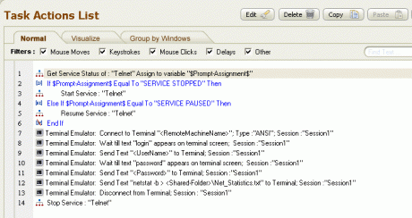](https://tekslate.com/wp-content/uploads/2017/11/T80-4.gif)

**How to run the task**

* In case you do not have Automation Anywhere installed, please download and install it from, http://www.automationanywhere.com/download/freeTrial.htm
* Download T80.atmx to location, My Documents\Automation Anywhere\Automation Anywhere\My Tasks
* Launch Automation Anywhere and from Task List select T80.atmx and click on RUN button to run the task.

**Example No: 2 – Using OCR to integrate with command line FTP**

**Task Description**

Web and Desktop applications are filled with images that need to be converted to a readable text for certain actions to be performed. OCR technology is used to do just that.

The task below logs into FTP server via DOS and waits to check if logged in successfully. It uses OCR technology to retrieve information from Command Prompt in to readable text to check whether login was successful.

T79.atmx

*Note: Save the xls in C: drive, the .atmx file in My Documents -> Automation Anywhere -> Automation Anywhere -> My Tasks*

Solutions

**Create a new task**

* Click on New->Task Editor

**Insert ‘Open Program/File’ command to open command prompt**

* Type ‘cmd.exe’ in program/file text box.
* Save the command.
* Enter necessary keystrokes required to log in to the ftp server.

[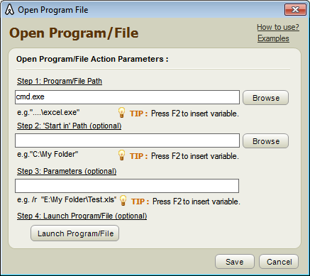](https://tekslate.com/wp-content/uploads/2017/11/T79-1.png)

**Insert Loop command**

* Insert 5 times loop command.

[](https://tekslate.com/wp-content/uploads/2017/11/T79-21.png)

**Insert OCR command to capture the text from command prompt.**

* Select window from the drop down.
* Click on view capture text.
* Select variable from drop down.
* Click on save button.

[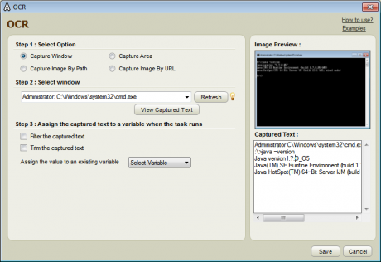](https://tekslate.com/wp-content/uploads/2017/11/T79-31.png)

**Enter if command to check logged in successfully or not.**

* Enter $str$ variable.
* Select ‘Includes’ operation.
* Select ‘Fix’ option.
* Type ‘logged in’ in fix text box.
* Save the command.

**Enter exit loop command in if condition.**

**Save and Run the task.**

*When you run this task, all the commands necessary to login to server are entered. It waits for some time to login to server. It uses the OCR technology to check whether login was successful or not.*

**Resource Credits** : [Automation Anywhere Examples](https://www.automationanywhere.com/27-examples)